**Name of the College: NIIT R.G.P.G College Meerut** 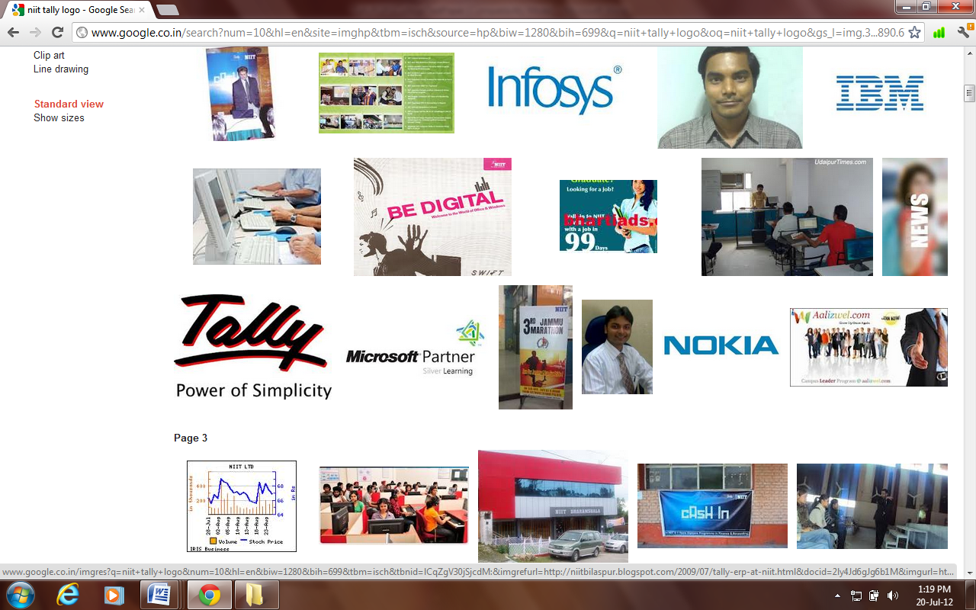

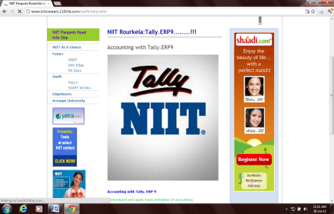 Student Name:________________________________Reg no:________________________

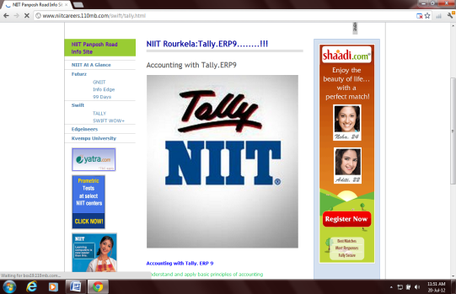 Class:______________Date:_________________Time:30 Min Max Marks: 100 M**arks** **B-Set-1**

**QUALIFYING EXAM OF TALLY**

|  |  |  |  |  |  |  |
| --- | --- | --- | --- | --- | --- | --- |
| **SN** | **QUESTION_STATEMENT** | **ANS_A** | **ANS_B** | **ANS_C** | **ANS_D** | **Ans** |
| **1** | **In Tally we can maintain** | **Inventory only** | **Accounts only** | **Account with Inventory** | **Both B & C** | **D** |
| **2** | **Depositing cash to SBI should be passed through** | **Payment mode** | **Receipt mode** | **Contra mode** | **Purchase** | **C** |
| **3** | **Under which head Motor Car is shown?** | **Current Assets** | **Fixed Assets** | **Sundry Creditors** | **Sundry Debtors** | **B** |
| **4** | **Tally by default provides** | **5 ledgers** | **4 ledgers** | **2 ledgers** | **no ledgers** | **C** |
| **5** | **Through which configuration we can activate Dr / Cr instead of To / By ?** | **F11** | **F12** | **Alt+F3** | **None** | **B** |
| **6** | **Bank OCC Accounts is the alias of** | **Bank Accounts group** | **Bank Overdraft group** | **Both** | **None of these** | **B** |
| **7** | **In Tally Simple and Compound Interest can be charged.** | **True** | **False** |  |  | **A** |
| **8** | **F12 - Key is also known as** | **Configuration window** | **Company Features window** | **Company Properties window** | **None of these** | **A** |
| **9** | **Bad Debts are recorded through** | **Contra mode** | **Journal mode** | **Receipt mode** | **Payment mode** | **B** |
| **10** | **. In Tally We Can Split Company Data for** | **3 Months** | **4 Months** | **6 Months** | **all of the above** | **D** |
| **11** | **Tally can warn on negative balance of Cash.** | **True** | **False** |  |  | **A** |
| **12** | **What is the short cut key of Bank Payment and Bank Receipt Voucher respectively?** | **F4 and F5** | **F6 and F7** | **F5 and F6** | **None** | **C** |
| **13** | **To switch from Profit & Loss a / c to Balance Sheet we will use** | **F10** | **alt + 10** | **F11** | **Ctrl + F12** | **A** |
| **14** | **At the time of ledger creation the shortcut to create online Group / Subgroup is** | **Insert key** | **Ctrl + C** | **Alt + C** | **Ctrl + Enter** | **C** |
| **15** | **Depreciation ledger falls under** | **Indirect Incomes** | **Fixed Assets** | **Indirect Expenses** | **Direct Incomes** | **C** |
| **16** | **Can we Create two Company having same name ?** | **yes** | **no** |  |  | **A** |
| **17** | **Outstanding bill report can be seen from** | **Display - Inventory Book- Outstanding** | **Display - Accounts Books - Outstanding** | **Display - Statement Of Accounts - Outstanding** | **None of these** | **C** |
| **18** | **In purchase bill we can given Tracking Number** | **TRUE** | **FALSE** |  |  | **B** |
| **19** | **Payment is an _____________.** | **Accounting voucher** | **Inventory voucher** | **Optional voucher** |  | **A** |
| **20** | **Started Business with cash Rs 100000.** | **Contra mode** | **Payment mode** | **Receipt mode** | **None of these** | **C** |
| **21** | **Can we zoom any reports in tally ?** | **yes** | **No** |  |  | **A** |
| **22** | **To see existing ledgers of a Company choose** | **Gateway of Tally > AccountsInfo > Ledgers > Create** | **Gateway of Tally > Accounts Info > Ledgers > Display** | **Gateway of Tally > Accounts Info > Ledgers > Alter** | **None of these** | **B** |
| **23** | **Keeping a copy of data in other media is termed as** | **Tally Vault** | **Tally Audit** | **Restore** | **Backup** | **D** |
| **24** | **Stock categories can be maintained in Tally** | **True** | **FALSE** |  |  | **A** |
| **25** | **Debit Note vouchers can be used for** | **Sales Return** | **Sales Order** | **Purchase Return** | **Rejection Out** | **C** |
| **26** | **"The shortcut key ""to remove a line in a report""is"** | **Ctrl + R** | **Alt + L** | **Alt + R** | **Either (a) or (b)** | **C** |
| **27** | **The shortcut to Delete a Company is** | **Alt + Delete** | **Shift + Delete** | **Ctrl + Delete** | **Alt + D** | **D** |
| **28** | **How to switch between opened Companies** | **Alt + F3** | **F1** | **F3** | **F2** | **C** |
| **29** | **Cash ledger can be allowed in journal mode** | **true** | **FALSE** |  |  | **A** |
| **30** | **Company features are applicable with the current company only** | **True** | **FALSE** |  |  | **A** |
| **31** | **BOM Stands for** | **Base of materials** | **Bill of materials** | **Bill of matter** | **Bill of management** | **B** |
| **32** | **We can not keep e-mail address in Company Creation Screen** | **True** | **False** |  |  | **B** |
| **33** | **Is it possible to see the opening balance in trial balance** | **Yes** | **No** |  |  | **A** |
| **34** | **To maintain Godown with Inventory turn on the option** | **Maintain Locations in F11** | **Use Godowns in F12** | **Maintain Multiple Godowns in F11** | **Use Multiple Locations in F12** | **C** |
| **35** | **To view current balance of ledger during voucher entry turn on the option** | **Show Ledger Balances from F11** | **Show Ledger Current Balances from F12** | **Display Current Balance from F11** | **None of these** | **B** |
| **36** | **Is it possible to pass a payment entry in single entry mode** | **yes** | **no** |  |  | **A** |
| **37** | **Shut down a company means to delete a company** | **True** | **False** |  |  | **B** |
| **38** | **Cash to Bank transaction in Tally can be passed through** | **Payment Voucher** | **Contra voucher** | **Reciept voucher** | **Voucher Class** | **B** |
| **39** | **Drawings account will be assigned with the group** | **Profit and Loss with Debit balance** | **Capital Account with Debit balance** | **Capital Account with Credit balance** | **Profit and Loss with Credit balance** | **B** |
| **40** | **The shortcut key used to create a New Company** | **Alt + F1** | **Alt + F3** | **Both A & B** | **Alt + F2** | **C** |
| **41** | **There are ________ types of Unit of measurements** | **1** | **2** | **3** | **4** | **B** |
| **42** | **Expenses or Fixed Asset are allowed in Purchase Vouchers** | **True** | **False** |  |  | **A** |
| **43** | **Is it necessary to create at least one item for maintaining price List** | **True** | **False** |  |  | **A** |
| **44** | **To save a Voucher from any position press** | **F4** | **Ctrl + U** | **Ctrl + A** | **Ctrl + V** | **C** |
| **45** | **Trade Discount is a discount allowed on the of a commodity.** | **Selling Price** | **List Price** | **Purchase Price** | **Cost Price** | **B** |
| **46** | **User can print Confirmation of Statement of any ledger from Tally 9.0** | **True** | **False** |  |  | **A** |
| **47** | **We can see the daily break-up report in cash book by press** | **F8** | **F6** | **F2** | **Alt + w** | **B** |
| **48** | **A Voucher Types can be created** | **from scratch** | **based on existing voucher type** | **Either A or B** | **None of these** | **B** |
| **49** | **Which is not a Final Report of a Company?** | **Balance Sheet** | **Profit and Loss** | **Day Book** | **None of them** | **C** |
| **50** | **The ledger salary payable falls under the group** | **Current liabilities** | **Duty and taxes** | **Loan liabilities** | **All of the above** | **A** |